See below without pictures
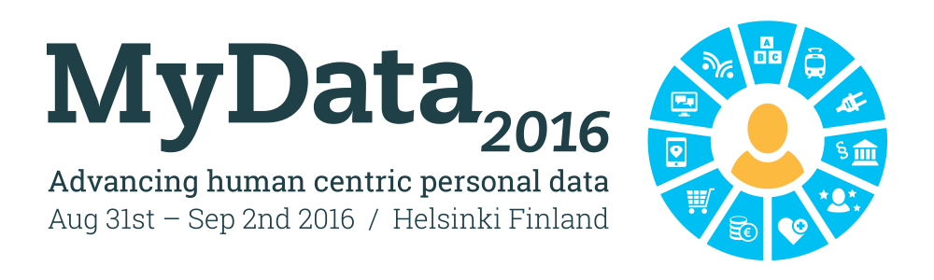
As you be, go and live, you leave trails of data everywhere. Which organizations know what is your favourite movie? Which organizations know what you bought from the supermarket yesterday? How to actually know what is known about you?

MyData is a Finnish born initiative from 2013, and now after EU General Data Protection Regulation (GDPR) was launched, it becomes more actual than ever. GDPR is the most strict data privacy regulation and will affect all organizations in the world. MyData2016 will try to find a solution where the individual data owners are placed in charge of their own data again.

International group of professionals, researchers, government members and activists will gather in Helsinki Hall of Culture to make MyData happen. At the same time with the conference and at the same location, Ultrahack MyData will create real life actualization proposals.

You are mostly welcome to join the event itself, or take part online!

INVITATION TO JOIN A CONFERENCE

As you be, go and live, you leave trails of data everywhere. Which organizations know what is your favourite movie? Which organizations know what you bought from the supermarket yesterday? How to actually know what is known about you?

MyData is a Finnish born initiative from 2013, and now after EU General Data Privacy Regulation (GDPR) was launched, it becomes more actual than ever. GDPR is the most strict data privacy regulation and will affect all organizations in the world. MyData2016 will try to find a solution where the individual data owners are placed in charge of their own data again.

International group of professionals, researchers, government members and activists will gather in Helsinki Hall of Culture to make MyData happen. At the same time with the conference, at the same location, Ultrahack MyData will create real life actualization proposals.

You are mostly welcome to join the event itself, or take part online!

Twitter Facebook Email

